**PRACTICAL 2: Conditional and loops**

**AIM:**

To write programs using conditionals and loops

**Theory:**

**Loops:**

* **Syntax:**

for (initial value; test; increment)

{

action1;

}

action2;

* **Diagram:**

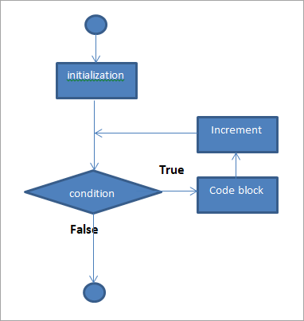

**Conditionals:**

* **Syntax:**

if (expression is true)

{

action1;

}

else

{

action2;

}

action3;

* **Diagram:**

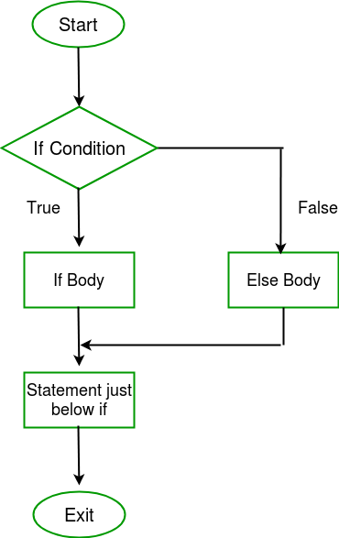

**Q1. Write a program in C++ that takes a number as input and prints its multiplication table up to 10.**

**CODE:**

#include <iostream>

using namespace std;

int main()

{

int num, mul;

cout << "Enter a number: ";

cin >> num;

for (int i=1; i<=10; i++)

{

mul = num * i;

cout << num << " x " << i << " = " << mul << endl;

}

}**OUTPUT:**

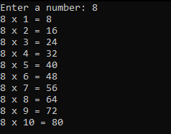

**Fig1. Output for C++ program to print its multiplication table up to 10**

**Q2. Write a C++ program which prints three highest numbers from entered 3 numbers**

**CODE:**

#include <iostream>

using namespace std;

int main()

{

int a, b, c, highest;

cout << "Enter 3 numbers: ";

cin >> a >> b >> c;

if (a > b && b > c)

{

cout << a << " is the highest number.";

}

else if (b > c)

{

cout << b << " is the highest number.";

}

else

{

cout << c << " is the highest number.";

}

}

**OUTPUT:**

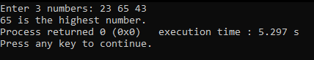

**Fig2. Output for C++ program which prints highest number out of 2 given numbers.**

**Q3. Write a C++ program to compute the sum of even numbers**

**CODE:**

#include <iostream>

using namespace std;

int main()

{

int num, sum = 0;

cout << "Enter a number: ";

cin >> num;

cout << "Numbers to be added: ";

for (int i=1; i<=num; i++)

{

if (i % 2 == 0)

{

cout << i << " ";

sum = sum + i;

}

}

cout << "\nTotal of all numbers is: " << sum;

}

**OUTPUT:**

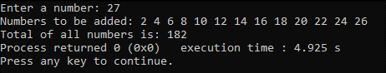

**Fig3. Output of C++ program to compute the sum of even numbers**

**Q4. Write a C++ program to accept side of a triangle and display equilateral, isosceles and scalene.**

**CODE:**

#include <iostream>

using namespace std;

int main()

{

int a, b, c;

cout << "Enter sides of a triangle: ";

cin >> a >> b >> c;

if (a == b && b == c)

{

cout << "It is an Equilateral triangle";

}

else if (a == b || b == c || a == c)

{

cout << "It is an isoceles triangle";

}

else

{

cout << "It is a scalar traingle";

}

}

**OUTPUT:**

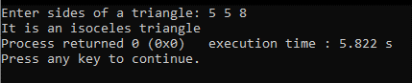

**Fig4. Output with the program identifying Isosceles triangle**

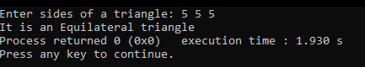

**Fig5. Output of the program identifying equilateral triangle**

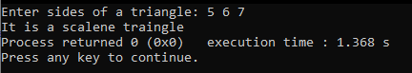

**Fig6. Output of the program identifying scalene triangle**